Effective Garbage Monitoring System Using GSM Module

**ABSTRACT**: Maintaining a clean and disease-free environment depends on efficient rubbish collection. However, dustbins all around the city frequently overflow and become clogged due to sporadic garbage collection. The goal of this project is to put in place a strong garbage monitoring system that prioritizes full bins and guarantees timely waste collection and disposal. An LED blinks to show the condition of a bin when an ultrasonic sensor determines that it has filled up. Additionally, the system uses a GSM module to connect with authorized staff at a nearby station. This method ensures that trash is routinely picked up from the fullest bins at the right times.

**Keywords:** LED,GSM Module, Ultrasonic Sensor and Monitoring System

**BLOCK DIAGRAM:**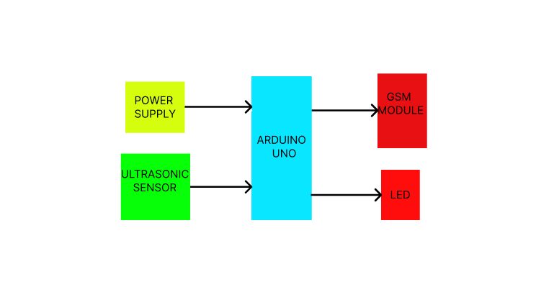

**MODULES:**

**Arduino UNO:** This development board, which interfaces with input and output devices, is the primary control unit for this project and makes use of the Atmega328p.

**Ultrasonic Sensor:** When trash builds up above a certain amount, these sensors can identify it and transmit a corresponding input signal to the Arduino UNO.

**GSM Module:** By using this communication module, the local waste disposal station can be notified of the filled bin's disposal priority.

**LED:** To discourage individuals from the immediate area from disposing of their garbage in the filled trashcan, an LED is utilized to show that it is unusable.

**Working Principle:**

* **Detection of Trash Level:** To continuously check the amount of waste, an ultrasonic sensor is positioned inside the trash can. This sensor notifies the Arduino UNO via input signal that the bin is full when the amount of trash reaches a predetermined threshold value.
* **Processing and Analysis:** To determine whether the bin is full, the Arduino UNO processes the signal it receives from the ultrasonic sensor. The system determines whether the waste has exceeded the threshold level by analysing this input.
* **Notification Trigger:** The Arduino UNO turns on the GSM module after the bin is verified to be full. The position of the bin and an alert regarding the priority of disposal are then sent by this module to the Android device of the designated trash disposal station.
* **Visual Indicator:** When the bin is full, an LED on the bin illuminates to alert those in the vicinity. People are deterred from adding more trash to the already full bin by this visual cue.

**EXISTING SYSTEMS:**

* **Manual Waste Management Systems:** Waste collectors travel predetermined routes to empty bins. Because bins could overflow before the planned pickup, this method frequently results in inefficient collection.
* **Basic Sensor-Based Monitoring:** Some methods use simple sensors to determine whether a bin is full. These systems do not, however, have integrated communication capabilities; instead, they depend on routine inspections by waste management personnel, which may still cause collection delays.
* **RFID-Enabled Waste Management**: Waste bins can be tracked using Radio Frequency Identification (RFID) technology. An RFID chip is attached to each bin, enabling identification and tracking when they are picked up. it is less successful in preventing overflow problems because it lacks real-time bin status monitoring.
* **IoT-Based Solutions:** Real-time reporting and monitoring are made possible by Internet of Things (IoT) solutions. In order to notify users when bins are full, these systems frequently incorporate Wi-Fi or GSM modules.

**PROPOSED SYSTEMS:**

* **Ultrasonic Sensor Integration:** The device will regularly check the garbage containers' fill level using ultrasonic sensors. This will improve operational efficiency by giving precise and up-to-date information on each bin's condition.
* **GSM Module for Communication:** When bins full to a predetermined level, a GSM module will be installed to instantly notify waste management staff. This avoids overflow situations and guarantees timely collection.
* **Data Logging and Analysis:** Over time, the system will record fill level data, allowing waste generation trends to be analysed. Based on actual usage, this data can be used to optimize routes and collection schedules.
* **User-Friendly Mobile Application:** Waste management employees will be able to examine bin status in real time and receive notifications using a smartphone application. This easy-to-use tool will speed up response times and simplify communication.

**ADVANTAGES:**

* **Improved Efficiency:** The technology minimizes overflow and missed pickups by alerting staff when bins are full, ensuring timely waste collection.
* **Real-Time Monitoring:** Bin fill levels can be continuously monitored to improve resource allocation and collection route optimization, which raises overall operating efficiency.
* **Cost-Effectiveness:** For waste management authorities, the method can result in significant fuel and labour cost savings by eliminating overflow and minimizing needless collection visits.
* **Environmental Benefits:** By reducing trash and encouraging appropriate waste management techniques, the system helps to create a cleaner environment, which eventually improves public health.

**DISADVANTAGES:**

* **Initial Setup Costs:** Some municipalities may be discouraged from implementing the system due to the substantial upfront costs associated with the acquisition and installation of sensors, GSM modules, and software.
* **Maintenance Requirements:** To guarantee dependable functioning, the sensors and GSM modules require routine maintenance, which raises operating expenses and resource allocation of the system.
* **Dependency on Technology:** Any interruptions in power or network connectivity could reduce the system's efficacy because it is highly dependent on technology and communication infrastructure.
* **Data Privacy Concerns:** Residents may become concerned about their privacy if trash levels and trends are collected; therefore, it is necessary to have clear policies on data usage and protection to handle any potential problems.